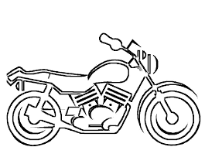
2nd Annual Motorcycle Ride
Sponsorship Details

Platinum Sponsorship - $500 +
- Entry for five (5) riders and admission for an additional five (5) to the after-ride reception ($175 value)
- Individual or Company Name will be listed as an event sponsor (you must provide your logo)
- Reserved table at the reception following the ride
- Company promotional materials may be distributed at the event (you must provide your materials)
- Company logo on all pre-ride promotional materials (you must provide your logo)
- Company logo to be printed on commemorative T-shirts (you must provide your logo)
Gold Sponsorship - $350
- Entry for three (3) riders and admission for an additional three (3) to the after-ride reception ($105 value)
- Name listed as an event sponsor (you must provide your logo)
- Company promotional materials displayed at the event (you must provide your materials)
- Company name printed on commemorative T-shirts
Silver Sponsorship - $200
- Entry for two (2) riders and admission for an additional two (2) to the after-ride reception ($70 value)
- Name listed as an event sponsor
- Company promotional materials displayed at the event (you must provide your materials)
Bronze Sponsorship - $100
- Entry for one (1) riders and one (1) admission to the after-ride reception ($35 value)
- Name listed as an event sponsor
- Company promotional materials displayed at the event (you must provide your materials)

We will gladly accept monetary donations in any amount.
Prize Donations
We would also greatly appreciate donations of gift certificates and merchandise to use for prizes at the event. Your individual / company name will be listed as a prize donor and your company promotional materials may be displayed at the event. (you must provide the materials)

Stratford PAL is a registered 501c(3) nonprofit by the Internal Revenue Service

